Room 1 Question 1
Incarcerated Femoral Hernia (reviewed by Dr. DeMaria)
Stem: 56 yo female presents to the emergency room with 18 hour history of nausea, vomiting, abdominal distension. Notes that she is otherwise healthy and was working in her garden yesterday and began to have pain in her right thigh radiating down the front of her leg. Thought it was a muscle strain so laid down for a couple hours but was awakened overnight by a feeling of nausea and abdominal pain and came to the emergency room.
PMH: HTN
PSH: None
Physical exam
- Afebrile
- Abdomen moderately distended, diffusely tender without rebound or guarding, no masses, + BS
- Rectal: Normal tone, no mass, GUAIC -
- Extremities: Firm tender mass with erythema at right superomedial thigh
Labs: WBC 11.4, Hgb 12.6, electrolytes K 3.3, otherwise normal
Imaging:
- CXR normal
- KUB: c/w dilated small bowel with multiple air fluid levels

What is your Differential Dx?:
- SBO due to
  - Hernia
  - Malignancy
  - IBD
  - Gallstone Ileus
  - Intussusception
  - Adhesions (less likely since no prior surgery)

What Would you like to do?
- Obtain CT
CT scan notable for findings c/w SBO with transition point posterior at right inguinal ligament with loops of bowel noted on superomedial right thigh

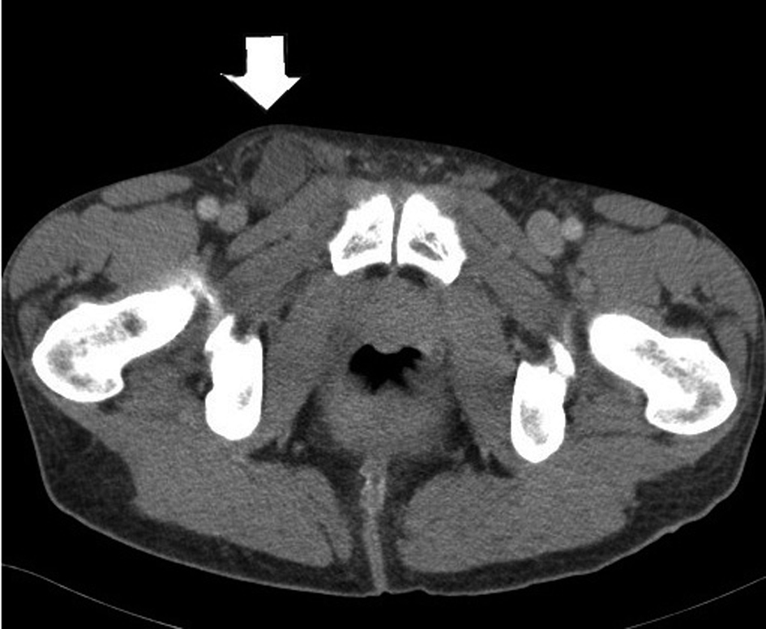

What is your diagnosis? Femoral hernia with Incarceration
What is your plan?
- Laparoscopic TAPP or TEPP
  - If attempt laparoscopically... ultimately unable to reduce
  - should be able to describe incising the fascia anterior to the hernia mass in order to try to reduce whether lap or open approach (DeMaria)

Open repair
  - Must describe opening inguinal ligament and then inguinal floor to access femoral hernia / examine hernia content then reduce

Open Lichenstein
- Oblique skin incision two fingerbreadths superior to inguinal ligament, carried through subcutaneous tissue
- External oblique fascia is identified and incised along direction of fibers
- Isolate cord structures from hernia sac
- Open hernia sac (ensuring caution for sliding hernia) or reduce contents back intraabdominally only after contents are examined.
- Incise inguinal ligament anteriorly if unable to mobilize hernia content due to incarceration.
- Polypropylene mesh secured to pubic tubercle medially, inguinal ligament inferiorly, rectus sheath/internal oblique superiorly

Should you use mesh if contents of hernia were ischemic? No … Resident should know to describe tissue repair.
- Reapproximate external oblique

  - Hernia repair plan if bowel ischemic? Tissue repair – McVay
    - A RLQ incision is made and the external oblique aponeurosis is opened through the external ring. Care should be taken to preserve the ilioinguinal nerve. Cooper's ligament is exposed.
    - A relaxing incision should be made to reduce tension from this tissue repair. The relaxing incision should extend from the just above the pubis superiorly in the plane of fusion of the external oblique aponeurosis and the anterior rectus sheath, exposing rectus muscle.
    - The hernia sac is dissected free, excised and then closed.
    - after decision is made about bowel resection- if possible the bowel should be exteriorized via the incision and run to make sure no ischemic bowel slipped back into abdomen.
    - Preperitoneal tissues are closed with a running absorbable suture.
    - Starting medially, Interrupted sutures are then placed between the transversus abdominis and Cooper's ligament, then transition suturing to the femoral sheath, avoiding the femoral vein which lies beneath the opened floor just anterior to Cooper’s ligament.
    - The repair is then continued laterally with sutures between transversus abdominis and the shelving edge of the inguinal ligament.
    - The spermatic cord exits through the newly created internal ring.
    - The external oblique is closed over the top of the spermatic cord.

Room 1 Question 2

Intususspetion (Reviewed by Dr. Longshore)
Stem: : 8 month old male, otherwise healthy presenting about a week after an upper respiratory infection with 6 hours of intermittent crying and bringing his legs to his chest followed by vomiting. In between the episodes he acts normal and playful. Vital signs are within normal limits, he has no previous surgical or medical history. Physical exam demonstrates no evidence of inguinal or umbilical hernias, palpable mass in the right mid abdomen on abdominal exam, non-peritoneal.
KUB demonstrates dilated small bowel loops with air-fluid levels

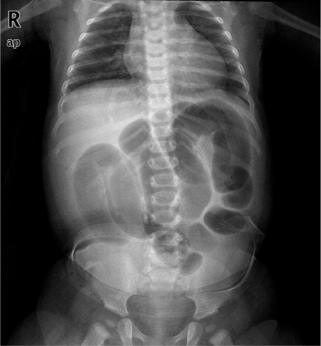

What is your Differential Diagnosis?
1.Intussusception
2. Constipation
3.Meckel’s diverticulitis
4.Appendicitis Gastroenteritis
What additional Workup or Studies?
US of the right lower quadrant demonstrates a target sign suggestive of intussusception

What would you like to do now?

- IV access, 20 ml/kg bolus of NS
- Obtain an air-contrast enema for reduction of the intussusception

What If recurs?
- Repeat enema process.

What if unable to reduce the ileocecal intussusception with air contrast enema?

- OR for exploratory laparotomy through transverse RLQ incision (MIS laparoscopic option is acceptable)
  - Place NG tube
  - Milk the intussusceptum retrograde into the proximal bowel with slow constant squeezing,
(NOT only pull on the proximal bowel to reduce it)

Still unable to reduce? Resection with primary anastomosis

Scenario 2: Same patient with two days of intermittent pain, bloody-mucous stools, now with tachycardia, distention, and involuntary guarding on abdominal exam?
- OR for exploratory laparotomy.

Room 1 Question 3

Breast Cancer Pregnanacy (Reviewed by KC)
Stem: A 30 year old G3P2 female presents in her 9th week of gestation with a palpable right breast pain and asymmetry. Her history is significant for a postpartum breast abscess with her second pregnancy three years prior that required incision and drainage. Her past medical and surgical history is otherwise unremarkable. She denies a family history of breast, gynecologic, or other cancers. On physical exam, there appears to be retraction of the right breast and right nipple with a palpable retroareolar mass, measuring approximately 4 cm ‘s in size. The right breast appears larger than the right breast but is without skin changes or palpable masses. There is no palpable axillary lymphadenopathy.

What is your differential diagnosis?
- Breast abscess
- Fibroadenoma
- Fibrocystic disease
- Galatocele
- Cyst
- Phyllodes tumor
- Breast cancer

What Additional Workup or Studies you need?!
- Ultrasound : Reveals a 3 cm retroareolar mass in the right breast, axilla is unremarkable.
- Mammography: Reveals a 3 cm x 2 cm x 6.3 cm mass involving the nipple-areolar complex on the right, the left breast is unremarkable.
- Core biopsies of breast: high-grade invasive ductal carcinoma, ER/PR (-),
Her2/Neu (-)
- Stage with chest XR and liver US: negative (CT scans / Bone scan not performed because of pregnancy)
- Ensure BRCA mutation testing given receptor status and age
- Maternal fetal medicine consultation
- Given triple negative status, can consider neoadjuvant chemotherapy with Adriamycin and Cytoxan (antimetabolites and Herceptin are contraindicated in pregnancy)
- Proceed to surgery in 2nd trimester
- Monitor fetal heart tones via Doppler pre- and postoperatively.
- Blue dye mapping is contraindicated in pregnancy; technetium-99 sulfur colloid is safe in 2nd/3rd trimesters

Scenario 1: Same patient but tumor receptors are ER/PR (+), Her2/Neu (+)

- If possible, initiate treatment during second trimester.
- Breast conservation is not recommended in first trimester (adjuvant radiation is absolute contraindication)
- Postpartum endocrine therapy, Herceptin is contraindicated during pregnancy.

Scenario 2: Same patient but presents with ipsilateral palpable lymphadenopathy; ultrasound reveals abnormal right axillary lymph nodes.
- Axilla FNA: Reveals triple negative metastatic disease.
- CXR and liver US: negative
- Modified radical mastectomy OR can consider neoadjuvant chemotherapy without radiation.
- Assess fetal heart tones via Doppler pre- and postoperatively.
- Initiate adjuvant chemotherapy six weeks postoperatively (no antimetabolites)
- Discontinue prior to delivery to avoid immunosuppression in the peripartum period.
- Complete unfinished chemotherapy cycles postpartum.
- Chest wall radiation postpartum

Scenario 3: Patient presents in her 29th week of pregnancy with axillary node negative disease.

- Total mastectomy vs breast conservation with SLNB w/ Tc-99 vs neoadjuvant chemotherpay
- Intraoperative electronic fetal heart rate and contraction monitoring.
- Chemotherapy if indicated.
- Postpartum XRT if BCT pursued.
- Postpartum endocrine therapy depending on receptor status

Scenario 4: Patient diagnosed with invasive breast cancer in her 35th week of gestation.
Postpartum treatment.

